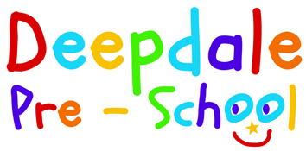

Lunch Club Policy

Lunch should be a relaxing, educational, and social activity and practitioners will promote healthy eating awareness and courteous behaviour.

- Children will be encouraged to fulfil personal hygiene practices.
- No swapping or sharing of food between children will be practised.
- Any residue lunch will be returned home.
- In the event of forgotten lunches, we are able to provide refreshment.
- In the event of allergy sensitive diners, all parents will be advised and asked if these foods can be avoided.
- Children will be encouraged to eat savouries prior to sweet additions.
- Healthy snack box information is available.
- Children will be encouraged to manage their lunch boxes e.g., packing and unpacking, however staff are available to open packaging/ cut fruit if requested.
- Food storage and service areas are prearranged and upheld in accordance to our Food Hygiene policy.
- The premises are secured and toileting, etc is monitored to ensure safety.
- Ratio of staff to children will be as in session 1-4 2 yr olds and 1-8 for 3-4 yr olds.
- Plates, spoons, forks. Etc will be made available.

