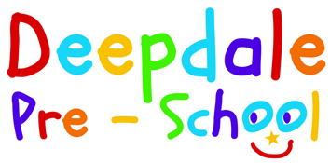
General Data Protection Regulations Compliance

Dear
Here at Deepdale Pre-school we take your privacy seriously.
We only keep information that is required under government legislation and for the time period specified.

The personal information that we need in order to :
- Register your child to the pre-school
- Record you child’s personal information.
- Record parent’s personal information.
- Record any special needs/requirements.
- Record Injuries.
- Record Nappy changing.
- Record observations/progression
- Record contact details.
- Record exchanges with other agencies.
- Invoice payments
- Share information
Will be held in a secure cabinet or be protected in pass worded software.

There are times when we need to contact you for various purposes. We are now obliged to request your consent under the new general data protection regulations (GDPR) to contact you via:
- Post
- Email
- Telephone
- Text message
You can opt out of this at any time and ask for all of your personal information to be removed.
I agree that you may contact me by any of the above methods
Signature:_______________________________ Date___________________

