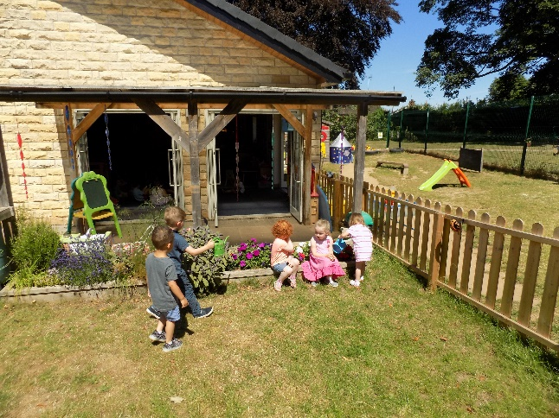
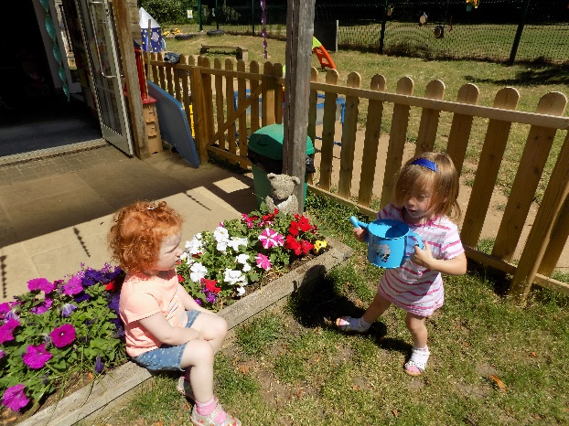
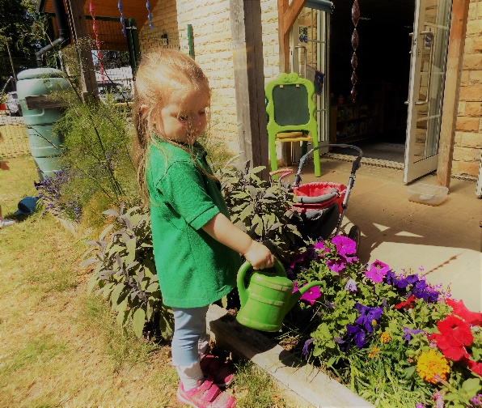
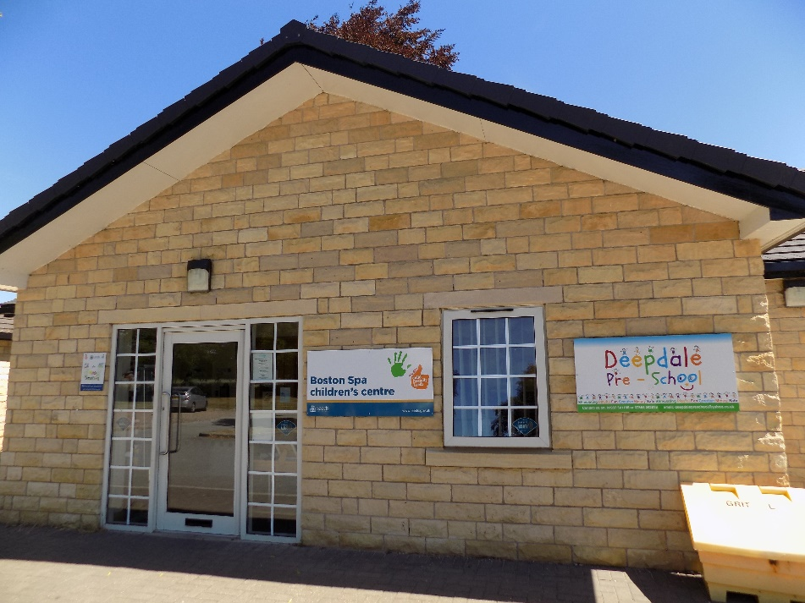

Deepdale Pre-School, Private Childcare for children between 2 – 5 years
A warm Welcome to Deepdale Pre-school
Deepdale Pre-school is a well-established private childcare provider, managed by a team of experienced and caring staff. The Pre-School has an excellent long-standing reputation. Our mature, qualified, and experienced staff are all dedicated to the development of the children in their care. The children’s learning experiences are based around their individual developmental needs and these needs will be identified by their key person in partnership with you as a carer. There are always lots of stimulating activities on offer and plenty of fun things to do, giving the children in our care lots of opportunities to learn both indoors and outdoors. All our team are qualified to, a minimum of NVQ level 3 and are highly experienced in early year’s childcare, Education and Welfare.
The Pre-school setting
Deepdale Pre-school is based in Boston Spa in a modern purpose-built building. The premises are shared with children’s services and offers a spacious and light environment for children to develop with a wonderful green area around us.
We also have a very spacious outside area where children can enjoy activities in all kinds of weather. The outdoor play area offers children the opportunity to develop their physical and co-ordination skills whilst allowing them to take risks and challenges to enhance their personal development. The outdoor area also gives us the opportunity to do some planting and learn how things grow, how to care for living things, the environment and also give the children a sense of achievement, seeing the visual effect of their efforts as the plants/ vegetables grow. We are open Monday to Friday from 8am to 3pm and follow Leeds educations school calendar. We offer flexible day care for 2 -5-year olds, which includes morning and afternoon sessions with optional breakfast and lunch clubs. All this is offered in a safe, fun and stimulating environment.
Practical Help
Under government legislation all children are eligible for 15 hours free childcare each week starting in the term after their third birthday. Since September 2017, the government have been offering 30 hours free childcare for working parents, (please enquire in the office). In addition to this, extra sessions are available if you wish. We also offer places for two-year olds including government funded children that meet the criteria for eligibility. Please ask if you think you may be eligible.
Our Commitment
Our aim is to prepare children for school, and we offer a structured development plan for this. The indoor section is divided into areas where children can focus on certain learning objectives, story time, arts and crafts and role play. There is a designated quiet area where younger children can remain within their daily routine and have a daytime nap if required. Working in partnership with parents Deepdale operates a key worker system where your child is allocated to a key member of our team who will support both you and your child’s needs. The key worker will build a bond with your child to help them feel safe and secure in their new environment. The key worker is also responsible for building up a profile on your child. This will be in the form of an online system called Tapestry that will enable you to access written observations, photographs, and an insight into what your child does on a daily basis. You will also be able to view your child’s progress and what their next steps are. This will allow you to work in partnership with our pre-school ensuring that any gaps in your child’s learning is identified and addressed. Your child’s key person will plan activities for your child based on their interests and abilities and will aim to support them to reach their maximum potential. A copy of the profile can be downloaded by parents/carers at the end of the child’s time at pre-school so that they can keep a record of their child’s achievements. The information collected will also be used to provide information for your child’s prospective reception teachers, as they are invited to visit the pre-school. More detailed information about the Pre-school, our policies and day to day procedures are available on request. The policies are designed to give information for staff and parents on such areas as child protection, health and safety, sickness, diet and nutrition.
What do I need to do to secure a place at Deepdale?
If you would like to arrange a meeting with our Management team, they will talk you through the registration process and show you and your child around the nursery.
If you want to secure a place you should complete the child registration form, which is inside our ‘welcome pack’ or email Deepdalepreschool@yahoo.co.uk. Please note places can only be secured once the first half term invoice has been paid
How can you contact us? Out of hours emergency number: 07896281081
The Pre-school address; Deepdale Pre-school, Deepdale Lane Boston Spa Leeds LS23 6EH Tel: 01937 541188 Mobile: 07854 092616
 | 3 and 4-year-old rates | 2-year-old rates
Full day care 9am -3pm | 41.00 | £45.00
Breakfast club 8am to 9am (incl. breakfast) | £7.00 | £7.00
Morning session 9am – 12pm | £21.00 | £22.50
Lunch club 12pm-1pm | £6.50 | £6.50
Afternoon session 12pm-3pm | £21.00 | £22.50
Late pick up charge per 15 min  Late payment fee per invoice | £10  £20 | £10  £20
Deepdale Pre-school Nursery Fees

Invoices are raised half termly in advance. A half term’s notice period is required to reduce or cancel session.
Invoices are revised in March of each year

Frequently Asked questions
My child is sick what should I do? Call a member of the nursery team on telephone number: 01937 541188 or mobile: 07854 092616 as soon as possible and they will, dependent on the illness, advise the period of time your child should remain absent from Pre-school.
What happens at lunch time? We ask that children bring their own “healthy” lunch for lunch times. We also ask parents not to pack any products which may contain nuts or fish as this may be harmful to other children.
I want to take a last-minute holiday. Please complete a Holiday form. Please note credit neither monetary nor in extra sessions can be given for holidays.
What should I bring to Pre-School? Each day a bag containing a change of clothes, wipes, nappies and nappy bags (if still in nappy’s), sun cream and a sun hat (during the summertime). Please check the contents of the bag on a regular basis.
What if I am running late for pick up? Please notify the Pre-school immediately. A late collection fee may be applied to your account.
My child has an allergy. Please notify staff prior to your child starting pre-school. Please note fish and nut allergies are potentially life threatening therefore we do not allow fish or nut products in nursery.
When will I receive an invoice and how do I pay? Invoices are sent out at the beginning of each half term and are payable within 14 days. Payment can be made by Bank transfer or Childcare vouchers.
I am preparing for toilet training. Our staff team will work with you to support your child during this important period. Just let your child’s key person know when you have started, and we will tackle the job together.
What should my child wear to Pre-school? Children can get very messy at pre-school, so we suggest that children do not wear their best clothes! To make the decision easier we do supply children’s uniforms which can be purchased through the pre-school. If required, please make your request as soon as possible to a member of pre-school staff.
My child is not settling in, what do I do? We have a settling in policy where we work together with the parent and key person to ensure we find a way suited to your child to help them settle in.
What do I do if I have a query or a complaint? If you have any concerns at all, please contact Kathy Hudson at Deepdale Pre-school to discuss your concerns on 07854 092616 or 01937 541188. Out of hours 07896281081
What should I do if I will not be the person picking up my child? Safeguarding of children is essential so if you will not be picking up your child you must inform the pre-school when they are dropped off or in the case of an emergency, please contact the pre-school on 07854 092616 or 01937 541188.
Copy of our Complaints policy & Procedures is available on request or via our website.

Out of hours emergency number: 07896281081

Rising Five’s

Rising Five’s is a specialised group aimed at children we believe are developmentally ready for a more structured session, usually our older children who we can prepare for school. These sessions start at the beginning of the last term when we believe that the children are ready to take on more focused sessions.
The sessions are staffed by qualified nursery staff who have completed a level 3 qualification or above in Pre-school practice and early year’s education. The aim is to plan more structured sessions that will enable us to help the children progress and extend their learning whilst continuing to have fun and develop each child in their personal interests.
Rising 5’s is delivered in partnership with parents and at the end of each week we offer a task sheet ‘homework’ for you to complete at home with your child. Its good fun and although not compulsory gives many parents chance to show off their creative nature with their child!
Rising 5’s is a unique service offered by Deepdale Pre-school which is invaluable to children about to start school. We are very proud of all our learning and nurturing initiatives including Rising 5’s. The sessions provide an excellent grounding for learning in Life.

Based on the Early Years foundation Guidelines the areas of learning are split into three prime areas:
- Personal, social and emotional development
- Language and communication
- Physical development
The prime areas are achieved through introducing and building confidence in:
- Literacy
- Mathematics
- Knowledge of the world
- Expressive art’s and design
Rising 5’s is not a focus on teaching Maths, English or Reading, but preparing your child with the skills they will need to be ready for learning in reception, such as listening, learning to be independent, kind, take turns, all the social and emotional skills that are needed to make the transition to reception easier.

Child Registration Form
Child’s Details
Child’s name . . . . . . . . . . . . . . . . . . . . . . . . . . . . . . . . . . . . . . . . . . . . . . . . .
Preferred child’s name (if shortened) . . . . . . . . . . . . . . . . . . . . . . . . . . . . .
DOB . . . . . . . . . . . . . . . . . . . . . . Please produce a copy of birth certificate.
Male/Female/Non-Specific. . . . . . . . . . . . . . . . . . . . . . . . . . . . . . . . . . . .
Child’s position within the family . . . . . . . . . . . . . . . . . . . . . . . . . . . . . . . . .
Child’s nationality (optional). . . . . . . . . . . . . . . . . . . . . . . . . . . . . . . . . . . .
Religion(optional) . . . . . . . . . . . . . . . . . . . . . . . . . . . . . . . . . . . . . . . . . . . . . .
First language . . . . . . . . . . . . . . . . . . . . . . . . . . . . . . . . . . . . . . . . . . . . . . . .
Other languages spoken at home . . . . . . . . . . . . . . . . . . . . . . . . . . . . . . . .
Address . . . . . . . . . . . . . . . . . . . . . . . . . . . . . . . . . . . . . . . . . . . . . . . . . . . . .
. . . . . . . . . . . . . . . . . . . . . . . . . . . . . . . . . . . . . . . . . . . . . . . . . . . . . . . . . . . . .
Does your child have any interests or hobbies? . . . . . . . . . . . . . . . . . . . .
Does your child have any favourite toys or teddies? . . . . . . . . . . . . . . . . .
. . . . . . . . . . . . . . . . . . . . . . . . . . . . . . . . . . . . . . . . . . . . . . . . . . . . . . . . . . . . .

Is there any other specific information that may be helpful for you to share with us about your child?
. . . . . . . . . . . . . . . . . . . . . . . . . . . . . . . . . . . . . . . . . . . . . . . . . . . . . . . . . . . . .
Does your child attend any other setting? Yes / No
If yes, please provide details of setting and days attended:
. . . . . . . . . . . . . . . . . . . . . . . . . . . . . . . . . . . . . . . . . . . . . . . . . . . . . . . . . . . . .
Are any other agencies involved with your family? Yes / No
If yes, please provide details:
. . . . . . . . . . . . . . . . . . . . . . . . . . . . . . . . . . . . . . . . . . . . . . . . . . . . . . . . . . . . .

Parent’s Details
Parent/Guardian names with parental responsibility
. . . . . . . . . . . . . . . . . . . . . . . . . . . . . . . . . . . . . . . . . . . . . . . . . . . . . . . . . . . . .
Home telephone number . . . . . . . . . . . . . . . . . . . . . . . . . . . . . . . . . . . . . . .
Mobile numbers . . . . . . . . . . . . . . . . . . . . . . . . . . . . . . . . . . . . . . . . . . . . . .
Email address . . . . . . . . . . . . . . . . . . . . . . . . . . . . . . . . . . . . . . . . . . . . . . . .
Occupations . . . . . . . . . . . . . . . . . . . . . . . . . . . . . . . . . . . . . . . . . . . . . . . . . .

Pre-school Requirements
Preferred date of entry . . . . . . . . . . . . . . . . . . . . . . . . . . . . . . . . . . . . . . . .
Sessions required (please tick)
Day | Breakfast 8am – 9am | Morning 9am – 12pm | Lunch club 12pm – 1pm | Afternoon 12pm-3pm
Monday
Tuesday
Wednesday
Thursday
Friday
Please provide 3 emergency contact names and numbers
1 . . . . . . . . . . . . . . . . . . . . . . . . . . . . . . . . . . . . . . . . . . . . . . . . . . . . . . . . . . .
2 . . . . . . . . . . . . . . . . . . . . . . . . . . . . . . . . . . . . . . . . . . . . . . . . . . . . . . . . . . .
3 . . . . . . . . . . . . . . . . . . . . . . . . . . . . . . . . . . . . . . . . . . . . . . . . . . . . . . . . . . .
Health Details
GP’s name and address . . . . . . . . . . . . . . . . . . . . . . . . . . . . . . . . . . . . . . . . .
Surgery telephone number . . . . . . . . . . . . . . . . . . . . . . . . . . . . . . . . . . . . . .
Does your child receive speech language therapy, physiotherapy, or any other professional involvement? Yes / No
Are your child’s vaccinations up to date? Yes / No
If you choose not to immunise your child, please confirm that you understand that both your child and their nursery contacts are at risk of infection without medically advised, prescribed immunological cover? N/A / Yes / No
Does your child have asthma? Yes / No If yes please provide details of medication . . . . . . . . . . . . . . . . . . . . . . . . . If your child is using medication, please supply the setting with additional inhalers.
Does your child have eczema? Yes / No If yes please provide details of medication . . . . . . . . . . . . . . . . . . . . . . . . . If your child is using medication, please supply the setting with additional creams.
Does your child have any recurring illness or allergies? Yes / No Specific allergies such as nut, egg, plasters, etc. Please inform the nursery of any changes to these allergies and advise what necessary interventions you require in the event of accidental allergen contact. Please inform the setting of any new allergies that arise whilst at Pre-school. For nut allergies or any ongoing illness please supply a doctor’s letter stating the extent of the allergy/illness and details of epipen if needed.
Does your child have any special dietary requirements? Yes / No
If yes, please provide details . . . . . . . . . . . . . . . . . . . . . . . . . . . . . . . . . . . .
Is your child on any long-term medication? Yes / No
If yes please provide details . . . . . . . . . . . . . . . . . . . . . . . . . . . . . . . . . . . . .
If you have any other information which you think may be relevant to the care of your child, please provides details. . . . . . . . . . . . . . . . . . . . . . .
In case of emergency do you give your permission for staff to administer Calpol? Yes / No
I have read and agree to Deepdale Pre-school’s Terms and Conditions
Parent’s/ Guardian’s Signature . . . . . . . . . . . . . . . . . . . . . . . . . . . . . . . . . . Date. . . . . . . . . . . . . . . . . . . . . . . . . . .
Terms & Conditions Our obligations & Your obligations

1.Obligations on Deepdale Pre-school We will: 1.1 Select, employ and train experienced quality staff to a minimum of NVQ level 3. All staff are fully DBS checked and fully committed to ongoing training. 1.2 Provide cost effective quality childcare and to review quality at regular intervals. 1.3 Provide you with regular feedback on your child’s progress as and when requested. Specific feedback sessions can be arranged if requested. 1.4 Provide an environment that prevents the spread of infection. We have an infection control policy. This means if your child is ill, we can send them home to protect other children in our care. 1.5 Inform you as soon as possible if a place is available for your child/ children. 1.6 Try to accommodate any requests for extra sessions and/or increased sessions. 1.7 Provide you with at least 6 weeks’ notice when we close the nursery for training days. These training days will take place on different days where possible.
2. Obligations on You You will: 2.1 Confirm within 10 days of receiving notification of a place that you still wish to take up this place. 2.2 Sign and date our registration form and terms and conditions form to say you agree to our terms and conditions. 2.3 Provide a half term’s written notice to change your child’s session or withdraw your child completely. Request must be submitted a half term in advance to change a booking. 2.4 Keep us informed as to the identity of the person who will be collecting your child from our Pre-school. If the person collecting your child is not usually responsible, then Proof of identity will be required. 2.5 Immediately inform us if you are unable to collect your child from nursery by the official collection time on telephone: 01937541188 or mobile: 07854092616. 2.6 Inform us in advance as soon as possible if there are any dates where your child will not be attending nursery by completion of a Holiday information form. 2.7 Immediately inform us if there is any change to your contact details. 2.8 Inform us if your child is unwell/ suffering from a contagious illness and notify us immediately of any allergies/ ongoing medical conditions the child may have. Conditions such as sickness & diarrhoea, conjunctivitis and impetigo, children should abstain from nursery for 48 hours from the time the illness ends. Please inform staff of cases of chicken pox, measles, and scarlet fever asap. 2.9 When necessary complete a “Parent medication form” daily to allow us to administer appropriate medication. Please note all medication should have an up-to-date GP’s label present. 2.10 Inform us If any social care/ Child Protection orders are in place.
3.Payment
3.1 Our fees are based on term time only and will be invoiced in advance of each new half term. Our fee structure will be reviewed on an annual basis. 3.2 Fees must be paid within 14 days of receipt of invoice by BANK TRANSFER or childcare vouchers. Please note cash payments are not accepted. 3.3 If payment is not received in full within 14 days, we will send you a statement and a late payment fee of £20 per invoice will be added to your account. If payment isn’t received within the next 7 days, a further letter will be sent, which will incur a further charge. At this stage if payment hasn’t been received the matter will then be referred to our debt collection team. Late payment charges are stipulated in the nursery fee schedule and rates. 3.4 Please advise us as soon as possible if you are not able to make payment in full. 3.5 No credit (monetary or extra sessions) will be given to parents/carers for any sessions missed due to bank holidays/ training days or annual leave. 3.6 No credit will be given to non-funded parents for any annual leave, sickness or any other absence (notification is requested as an Ofsted requirement only). 3.7 There will be a charge to non-funded parents for any bank holidays, which fall within term time.
3.8 Childcare prices will be reviewed, and prices increased in March of each year.
3.9 There will be no charge to non- funded parents for training days, which fall on their allocated sessions. 4.0 If you fail to collect your child by/ before the end of the session, you will be liable for a late pick-up fee.

